|  |  |  |  |
| --- | --- | --- | --- |
| **SUPPLIER** | FABTECH | | |
| **PROJECT** | : EMPLOYEE MANAGEMENT SYSTEM | **P.O NO.** | : |
| **LOCATION** | : MALAYSIAN REFINING COMPANY SDN BHD | **PROJECT DOC. NO.** | : IUSB/FABTECH/UTM/19/01 |
| **EQUIPMENT** | : ENERGY MONITORING SYSTEM FOR OFF-GRID SOLAR POWER SYSTEM | **SUPPLIER DOC. NO.** | : FABTECH-UAT-001 |

USER ACCEPTANCE TEST

**TEST CASE (WEB BASED, ADMIN)**

|  |
| --- |
|  |

|  |  |
| --- | --- |
| **Test Case ID:** Test_FR-W10 | **Test Designed by:** |
| **Test Priority (Low/Medium/High):** High |  |
| **Module Name:** Web-based application |  |
| **Test Title:** The system must be able to authenticate the user to access the system | **Test Designed date:** 24/11/2019 |
| **Description:** Test the web sign in page | **Test Executed by:** |
|  | **Test Execution date:** |
|  |  |
| **Pre-conditions:** | |
| **Dependencies:** | |

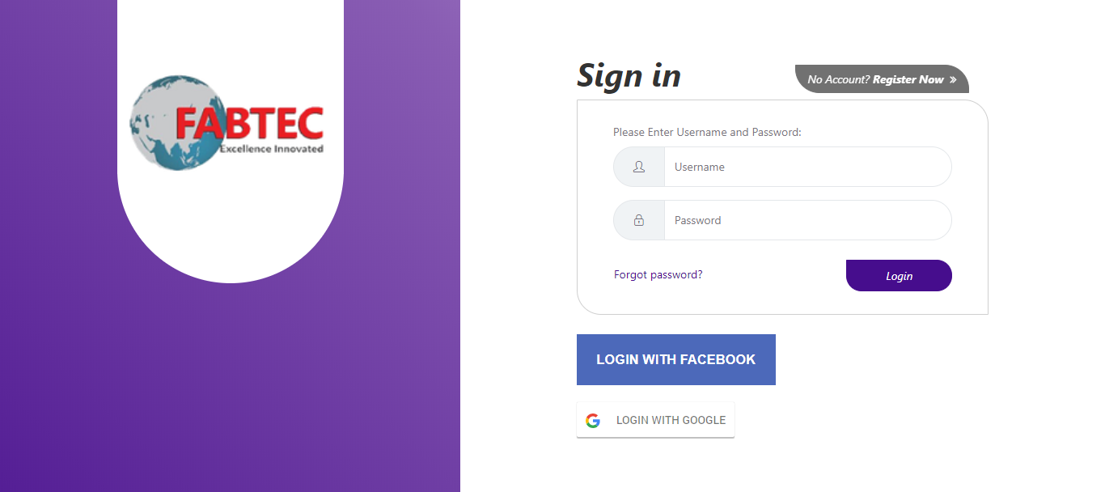

|  |  |  |  |  |  |  |
| --- | --- | --- | --- | --- | --- | --- |
| **Step** | **Test Steps** | **Test Data** | **Expected Result** | **Actual Result** | **Status (Pass/Fail)** | **Notes** |
| 1 | Launch the login web screen |  | The login screen will show up |  |  |  |
| 2 | Provide a valid respective username | Username = |  |  |  |  |
| 3 | Provide a valid respective password | Password = |  |  |  |  |
| 4 | Click on Login button |  | User should be able to login and enter Dashboard page |  |  |  |

**Post-conditions:**

User is validated and successfully logs in

|  |  |
| --- | --- |
| **Test Case ID:** Test_FR-W11 | **Test Designed by:** |
| **Test Priority (Low/Medium/High):** High |  |
| **Module Name:** Web-based application |  |
| **Test Title:** The system must provide the user the ability to view dashboard. | **Test Designed date:** 24/11/2091 |
| **Description:** Test the web dashboard page | **Test Executed by:** |
|  | **Test Execution date:** |
|  |  |
| **Pre-conditions:** User is registered and logged in (user is admin) | |
| **Dependencies:** | |

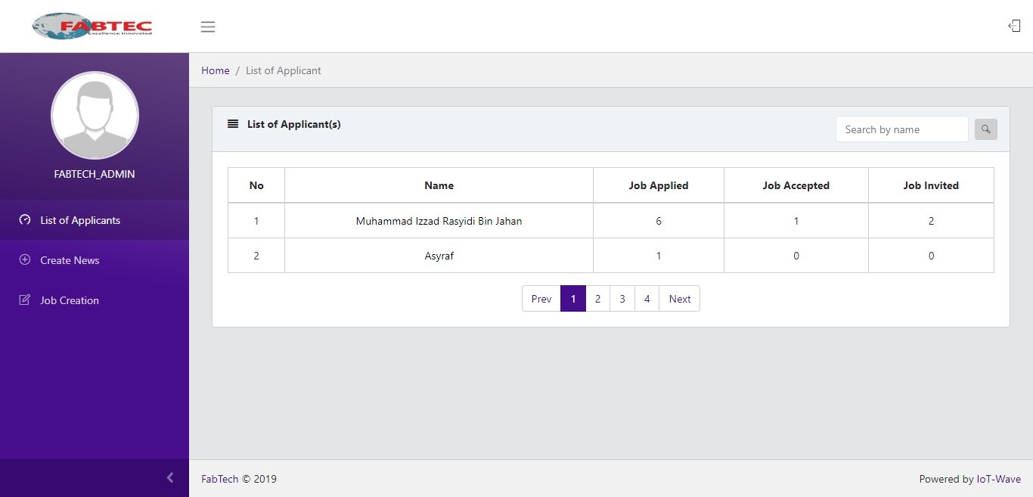

|  |  |  |  |  |  |  |
| --- | --- | --- | --- | --- | --- | --- |
| **Step** | **Test Steps** | **Test Data** | **Expected Result** | **Actual Result** | **Status (Pass/Fail)** | **Notes** |
| 1 | Launch the Dashboard screen |  | User should be able to view the dashboard |  |  |  |
| 2 | Click on Applicant’s Name |  | User should be redirected to Applicant’s Detail Page |  |  |  |
| 3 | Click on Applicant’s Job Applied |  | A pop-up of list of applied jobs by applicant will be shown |  |  |  |
| 4 | Click on Applicant’s Job Accepted |  | A pop-up of list of accepted jobs by applicant will be shown |  |  |  |
| 5 | Click on Applicant’s Job Invited |  | A pop-up of list of invited jobs by applicant will be shown |  |  |  |
| 6 | Navigate with the pagination |  | User should be able to navigate the table pages with the pagination |  |  |  |

**Post-conditions:**

Users successfully view the dashboard

|  |  |
| --- | --- |
| **Test Case ID:** Test_FR-W12 | **Test Designed by:** |
| **Test Priority (Low/Medium/High):** High |  |
| **Module Name:** Web-based application |  |
| **Test Title:** The system must provide the user the ability to view/review CVs & certificates. | **Test Designed date:** 24/711/2019 |
| **Description:** Test the Applicant’s Details Page | **Test Executed by:** |
|  | **Test Execution date:** |
|  |  |
| **Pre-conditions:** User is registered and logged in (user is admin) | |
| **Dependencies:** | |

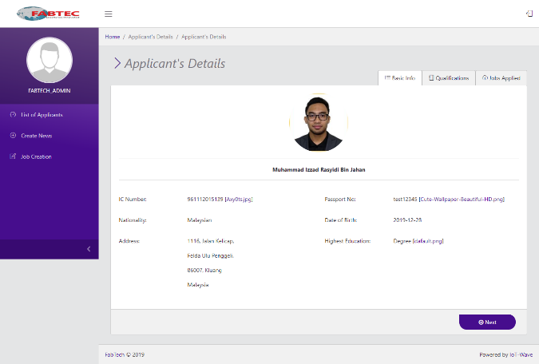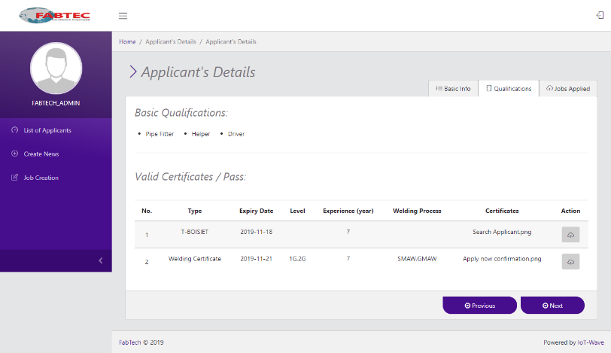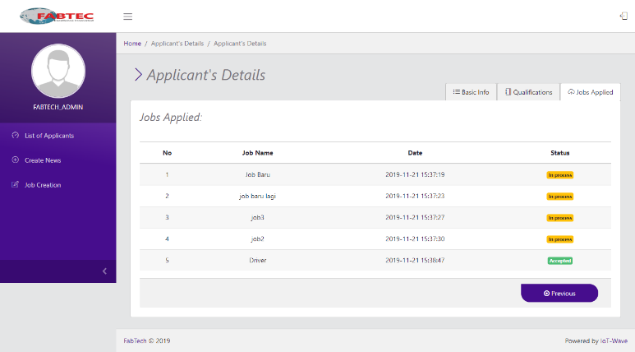

|  |  |  |  |  |  |  |
| --- | --- | --- | --- | --- | --- | --- |
| **Step** | **Test Steps** | **Test Data** | **Expected Result** | **Actual Result** | **Status (Pass/Fail)** | **Notes** |
| 1 | Click on Basic Info tab |  | User should be redirected to Basic Info tab |  |  |  |
| 2 | Click on Qualification tab |  | User should be redirected to Qualification tab |  |  |  |
| 3 | Click on Jobs Applied tab |  | User should be redirected to Jobs Applied tab |  |  |  |
| 4 | Navigate by previous and next button |  | User should be able to navigate by previous and next button |  |  |  |
| 5 | Click on download button next to certificates |  | User should be able to download applicant’s certificates and view them |  |  |  |

**Post-conditions:**

Admin can view Applicant’s Detail Successfully.

|  |  |
| --- | --- |
| **Test Case ID:** Test_FR-W13 | **Test Designed by:** |
| **Test Priority (Low/Medium/High):** High |  |
| **Module Name:** Web-based application |  |
| **Test Title:** The system must provide the user the ability to search Candidate db. | **Test Designed date:** 24/11/2019 |
| **Description:** Test the search bar in the dashboard page | **Test Executed by:** |
|  | **Test Execution date:** |
|  |  |
| **Pre-conditions:**  User is registered and logged in (user is admin) | |
| **Dependencies:** | |

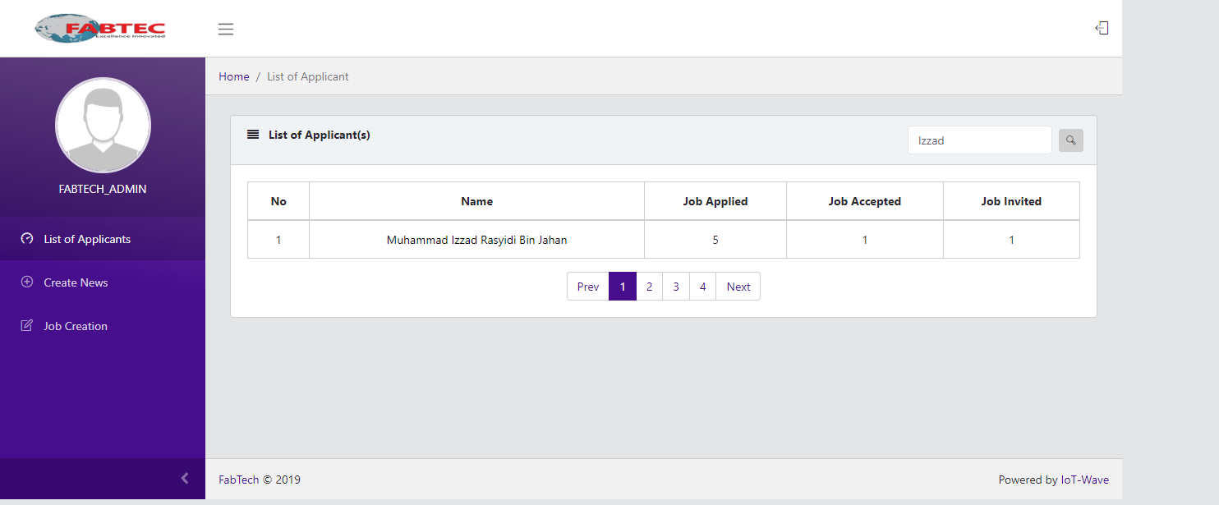

|  |  |  |  |  |  |  |
| --- | --- | --- | --- | --- | --- | --- |
| **Step** | **Test Steps** | **Test Data** | **Expected Result** | **Actual Result** | **Status (Pass/Fail)** | **Notes** |
| 1 | Input applicant’s name in the search bar |  | User should be able to see applicant’s name that matches the search bar input |  |  |  |

**Post-conditions:**

The user can use the search bar to find the applicants

|  |  |
| --- | --- |
| **Test Case ID:** Test_FR-W14 | **Test Designed by:** |
| **Test Priority (Low/Medium/High):** High |  |
| **Module Name:** Web-based application |  |
| **Test Title:**  The system must provide the user the ability to Auto/adhoc communication to all candidates. | **Test Designed date:** 24/11/2019 |
| **Description:** Test the Create News Page | **Test Executed by:** |
|  | **Test Execution date:** |
|  |  |
| **Pre-conditions:**  User is registered and logged in (user is applicant) | |
| **Dependencies:** | |

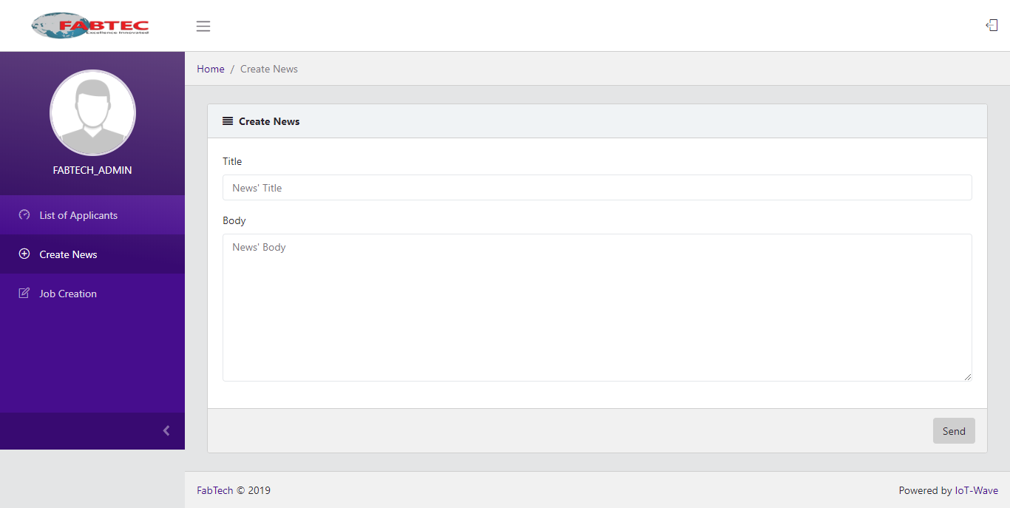

|  |  |  |  |  |  |  |
| --- | --- | --- | --- | --- | --- | --- |
| **Step** | **Test Steps** | **Test Data** | **Expected Result** | **Actual Result** | **Status (Pass/Fail)** | **Notes** |
| 1 | Launch the Create News screen |  | User should be able to view the Create News Page |  |  |  |
| 2 | Type in the News Title input |  | The typed inputs will show up on the input bar |  |  |  |
| 3 | Type in the News Body input |  | The typed inputs will show up on the input bar |  |  |  |
| 4 | Click on Send button |  | The news will be sent to all applicants |  |  |  |

**Post-conditions:**

User successfully view Create News page and create news